
10 Grade AP World History
Unit/Module 4
Suggested Duration: 24 Days
October 15, 2024-November 11, 2024
AP World History
Transoceanic Connections

Table of Contents
UNIT NARRATIVE 2
CONTENT STANDARDS 3
UNDERSTANDINGS AND QUESTIONS 3
ROADMAP 5
VERTICAL STANDARDS 15
VOCABULARY GLOSSARY 16

UNIT NARRATIVE

Between 1450 and 1750, European states, starting with the Portuguese and Spanish, sought a transoceanic route to Asia. Europeans established trading post empires in the Indian Ocean that inadvertently brought them into contact with the Americas. Trans-Atlantic trade linked the Americas, Europe, and Africa for the first time. European colonists who wanted sugar and other crops to sell in the global market developed plantations in the Americas. Their desire for laborers fueled the trade in enslaved Africans. Trans-Pacific trade flourished as well. Silver mined in Latin America were the major commodity. Over time, the transfer of crops, animals, and disease between the Eastern and Western hemispheres, known as the Columbian Exchange, altered life everywhere. The introduction of potatoes, corn, and tomatoes to Europe led to population growth. The introduction of deadly pathogens, such as smallpox and measles, devastated the populations of the Americas. Within the context of increasing European influence, regional commerce and established states in Afro-Eurasia continued to flourish. The Mughal, Ottoman, and Qing Empires expanded, creating ethnically diverse states. Across the globe, peasant and artisan labor intensified as the demand for goods and food intensified as demand for goods and food increased. These developments set the stage for the revolutions that defined the period after 1750.

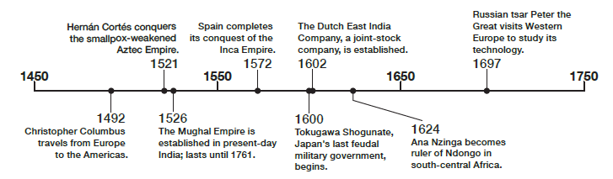

CONTENT STANDARDS
Below are the standards taught and assessed in this unit.

On Unit 4A Exam | Taught Content
U4.LOD: Explain the causes of the Columbian Exchange and its effects on the Eastern and Western Hemispheres.  U4.LOE Explain the process of state building and expansion among various empires and states in the period from 1450 to 1750.  U4.LOF Explain the continuities and changes in economic systems and labor systems from 1450-1750.  U4.LOH Explain how rulers employed economic strategies to consolidate and maintain power throughout the period from 1450 to 1750.  U4.LOI Explain the continuities and changes in networks of exchange from 1450 to 1750  UF.LOK Explain the similarities and differences in how various belief systems affected societies from 1450 to 1750.  U4.LOL Explain the effects of the development of state power from 1450 to 1750 | All content in the AP World History Course and Exam Description (CED) can be tested on the AP exam in May. The unit exam does not test all of the content in Unit 4. To see the CED follow the link or Curriculum Corner.  Link to CED

UNDERSTANDINGS AND QUESTIONS
Important big ideas and processes for the unit.

Key Concepts
KC-4.1 The interconnection of Eastern and Western Hemispheres made possible by transoceanic voyaging, transformed trade and had significant social impact on the world.
KC-4.2 Although the world’s productive systems continued to be heavily centered on agriculture, major changes occurred in agricultural labor, the systems and locations of manufacturing, gender and social structures, and environmental processes.
KC-4.4 Empires achieved increased scope and influences around the world, shaping and being shaped by the diverse populations they incorporated.

Key Questions
Maritime Exploration:
- How and why did states sponsor transoceanic exploration in the period 1450–1750?
Technological Innovations:
- Which technologies enabled European expansion across the globe, and how did these innovations build on earlier knowledge from other cultures?
Economic Change
- In what ways did new global trading systems transform economies and labor systems in Africa, the Americas, and Eurasia?
Cultural Exchange
- How did the Columbian Exchange affect populations, environments, and cultural practices in the Eastern and Western Hemispheres?
Social Hierarchies
- To what extent did global interactions between 1450 and 1750 reinforce existing social hierarchies or create new categories of identity and status?

